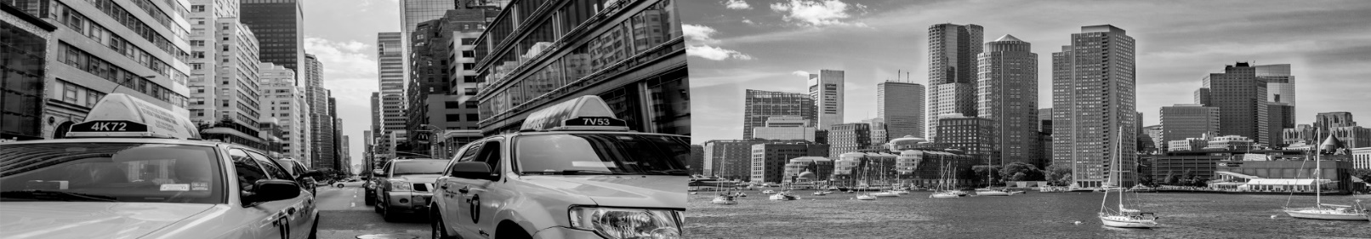

Together with the New York City Mayor’s office of the CTO we made an inventory of challenges NYC Agencies are confronted with. For which challenge can you offer solutions?
Building / Energy Efficiency  Manufacturing retrofit air source heat pumps for commercial buildings  Address Plug loads with smart outlet system  Incorporate Passive Haus concepts into NYC buildings  Alternative Refrigerants  Energy Generation  Integration of distributed renewable energy resources for dense urban environments  Floating Photovoltaics  Building-Integrated PV  Small scale renewable gas  Residential Solar Adoption  Combined Green Roof & PV Systems  Water Management  Quantify benefits of the existing Green Infrastructure (GI) progam  Using private property to manage public water (pay private owners for participation)  Water conservation through fixture retrofits, water recycling, and reuse, or real-time water quality monitoring (chemical and pathogen)  Smart release system for water storage  Shifting goals from public to private properties and focusing on roofs for water management  Waste  Innovation around transport/use (barge, trains) of biosolids  Litter reduction to keep waterways clear (problems with cigarette filters, wipes and solid waste) | Building Monitoring and Control Systems  Flexible fuel tank monitoring systems and associated reporting dashboards for connectivity to legacy systems  Wireless integration for proprietary control systems  3rd party module enhancements for CMMS/BMS integration  Energy Storage, Load Management and Peak Shaving  Increasing battery storage to weight/size efficiency ration  Non-flammable, commercial-scale battery technology  Analytics oriented solutions (whole portfolio and/or single facility)  Automation of load management  Peak Load Shedding  Battery storage, technology or deployment innovation  Air Quality  Reduce heating oil use in residential and commercial buildings  Limiting particulate matter emissions from open cookstoves in commercial kitchens  Enforcement to prevent idling of ICE vehicles  GHG Reduction  Urban scale carbon capture and sequestration  Technology that would help control nitrous oxide emissions from the wastewater treatment plant secondary process  Health  Mitigating Urban Heat Island Effect  Green AC Units / Combined Heating + Cooling Units
Which solutions can you offer to the challenge(s) you have selected?
Basic Information about your company
Year founded:
Number of Employees:
Country
Last year turnover (€)
Previous business experience with the US:
Previous business experience with other international markets
Additional information and contact details of the company
Company description
Contact details
Interest in joining the mission
What do you expect to achieve

